**HUANYING HOTEL ONLINE RESERVATION SYSTEM**

In Partial Fulfillment

of the Requirements for the Degree

Bachelor of Science in Information Technology

by:

**De Castro, Justin M.**

**Puras, Dexter T.**

**Parsan, Ken Cherish R.**

**CHAPTER I**

**INTRODUCTION**

**Project Context**

Like any other industry, the hotel business offers owners and guests socioeconomic prospects. It serves the purpose of offering consumers hospitality services. Customers are typically constrained in their attempts to find a room to spend the night because the customary procedure is to look for a hotel once you have arrived in the specific location, walk in, and see whether there is a vacant room. These customers can be travelers, foreigners, businessmen, tourists, visitors, etc. If there isn't a room available, you'll need to move on to the next nearest hotel and make another inquiry. What transpires, then, if you move around occasionally extremely late at night in quest of a room and all nearby hotels are full? Since we want to help the business get found online, we prefer making bookings online.

The newest low-cost hotel in Calapan, Oriental Mindoro, is called Huanying Hotel. They feature air-conditioned, modern-designed rooms with plush linens and mattresses. Their accommodations offer quite roomy bathrooms with granite countertops, hot water, and rain shower amenities. Modern conveniences including air conditioning, free WiFi, automatic door locks, and 40" flat screen TVs with cable channels are available in every room. Huanying Hotel is located at San Vicente Central, Calapan City, Oriental Mindoro. The Huanying Hotel still uses a manual booking process. Normally, after a booking book is full, it is dumped somewhere else and occasionally thrown away, which is not a smart practice because you can't analyze data to discover trends and make adequate planning. Since they are unable to maintain accurate records or facts, management is not thrilled about this. Since clients cannot independently book a room from any location, this may limit their ability to compete. In order to enable consumers to make reservations for everything they require from wherever they are before checking into a hotel, the research set out to create

An online hotel reservation system. The system should make it simple to access information, retrieve it, and generate reports.

**Problem Statement**

The hotel has only operated by Manual book keeping that caused Unsecured data Incovienient Customers retention

**Objectives of the Study**

Generally, the studies objectives are to develop and design Huanying Hotel Online Reservation System

Specifically, it aims to:

* Develop an online reservation system;
* Integrate online payment transaction;
* Corporate electronic mail and sms notification
* Evaluate the developed system using ISO 25010;
* Implement the developed to the respective client.

**Scope and Limitation of the Study**

The study focuses on developing an Huanying Hotel Online Reservation System.

The scope of this study includes the registration of the official staff of the Hotel in the website. The Huanying Hotel Official Website contains the staff management function exclusively for the Admin. The website also includes online payment for customer in order to reserve their rooms.

(a) All the exclusive features stated in this study are only for the admin and staff only.

(b) Persons that are not connected to the hotel can visit the website with limited features.

**Conceptual Framework**

*INPUT*

*=User log-in/Sign-up*

*=Customer’s Information*

*=Room reservation by customer*

*PROCESS*

*=Select room package*

*=Approval of reservation*

*OUTPUT*

*Huanying Hotel Online Reservation System*

**Conceptual Framework of the study**

Figure 1 demonstrates the idea behind the system's data processing from input to output. After receiving the data, the process involves analyzing it, managing it, and producing interpretations or outcomes. The output process entails producing reports or papers using the managed processing data. Input means the insertion of insertion from users.

**Definition of terms**

**Admin** - is a user with access to advanced administrative privileges and capabilities, such as creating user accounts, controlling system security, and carrying out maintenance procedures. The system is under the administrator's authority, and it is up to them to keep it operating efficiently and securely.

**Online Reservation** - to give users a simple, effective platform for making hotel reservations and managing their existing ones.

**Online payment** - The way of paying online after acquiring a reservation.

**Customer** - They are the ones who will get to use the online reservation.

**Transaction** - The process where in it takes the interaction between the customer and admin.

**Database** - serves as storage of inputted information in the website.

**Online Reservation** – Users to set up appointments for specific times and receive SMS or email reminders.

**Cancelation -** Canceling a customer reservation that has been made or planned.

**Room Blocking** - Set of rooms set aside for a customer reservation.

**CHAPTER II**

**REQUIREMENTS SPECIFICATION**

**REVIEW OF RELATED LITERATURE**

**Foreign Literature**

According to Kun-Shan Zhang, Chiu-Mei Chen, and Wen-Yu Chang's 2022 study, "Online Reservation Behavior of Hotel Catering Industry," more and more clients may now access a range of information and make reservations for restaurants through integrated booking systems. This essay examines how a person's perception of risk affects their propensity to use an online restaurant reservation system. SPSS24 statistical software was used to examine the hypothesis relationship and analyze the research outcomes after data was gathered via a questionnaire survey. This report confirms the positive impact of perceived risk on desire to use when consumers use the restaurant online reservation system using customers from a five-star hotel in Shekou, Shenzhen. The study shows that consumers' inclination to use the online reservation system is significantly impacted by how much cognitive risk they are exposed to. Finally, judgments and recommendations based on the facts are presented, and recommendations are made for how to improve the hotel online reservation system.

According to the study "Factors That Influence Online Behavior In Purchasing Hotel Room Via Website Among Tourist" by RAJA OMAR, RAJA NORLIANA, Nik Hashim, Zain, Ramlee, Abdul Halim, Ahmad Faiz, Mohd Rohzi, Amer Firdaus Nor Azlin, Mohd Hadi Asyraf Wat Mat, and Wan Muhammad Nuriman (2020), tourism is one of the fastest-growing industries in The characteristics that affect online booking behavior were examined in this work using a quantitative research strategy combined with descriptive research. These variables include independent ones like location, cost, safety, and facilities that could have an impact on how online reviews and valence reviews are influenced by the dependent variable, which is the hotel preference. The purpose of this study is also to investigate or describe how people use hotel reservation systems. The pattern of hotel reservations has also evolved from the traditional booking system to online and paperless reservations as a result of the rapidly expanding tourist and hospitality industries. The literature on tourism and hospitality, which still needs additional investigation, has been enriched by this study.

Takunya, Keneth (2022) conducted a study titled "Online hotel reservation system" with the aim of increasing bookings while reducing hotel prices. One of the problems at the hotel is that it formerly used to advertise its services on billboards and in public areas. In this case, the study's main objective was to develop an online hotel reservation system for the hotel in order to lessen these problems. The main methodology used was RAD from SSADM, where the functional modules are generated concurrently as prototypes and then integrated to construct the full product for quicker product delivery. Because there isn't a thorough preplanning phase, it is simpler to accommodate modifications throughout the development phase. I MySQL database server is one of the main tools that was utilized in the creation of an online hotel reservation system. Web technologies include things like HTML, PHP, CSS, JavaScript, and Hypertext Markup Language (HTML). In order to resolve the problems the hotel was having with its manual system, an online hotel reservation system was developed. This system enables the hotel to manage booking operations online and please their clients.

This study examines the strategic consumer choices made when booking hotels online. The study "Strategic consumer behavior in online hotel booking" by Lorenzo Masiero, Giampaolo Viglia, and Marta Nieto-Garcia found that free cancellation policies let customer’s rebook the hotel room at a later time should the price drop before the date of stay (2020). A discrete choice experiment is used to infer consumer preferences for free cancellation and non-refundable rates under various scenarios. In the study, the moderating role of customer risk attitudes is also explored. Risk-taking customers prefer free cancellation policies, which increase as soon as an automatic rebooking option is made available. Larger booking windows do boost the usefulness of the free cancellation rate, but as risk propensity increases, this effect weakens. For those working in the sector, the discovery of four unique consumer categories has significant ramifications.

“Hotel booking demand datasets” conducted by Nuno Antonio, Anade Almeida, and Luis Nunes (2019), state that this data article describes two datasets that contain information on hotel demand. Hotel H1 is a resort hotel, and Hotel H2 is a hotel in a city (H2). The 40,060 observations of H1 and the 79,330 observations of H2 are described by 31 variables, which are the same for both datasets. Each observation has a hotel reservation. Both files cover bookings that were planned to arrive between July 1, 2015, and August 31, 2017, including both confirmed and canceled reservations. Because this is real hotel data, all data components relevant to hotel or customer identification have been removed. Due to the scarcity of genuine business data for scientific and educational purposes, these datasets may be critical for research and instruction in revenue management, machine learning, or data mining, among other topics.

**Local Literature**

Users of an online application (2020) created by Patricia Nicole Ramos, Joshua Ocampo, Phil Matthew Matthew Fornal, and Michael Nayat Young can reserve seats on buses. Both those who plan bus trips and those who ride buses will find it to be easy to use. All customer data is tracked, including bus data like route, seat, arrival time, departure time, and fare. Because the pandemic forbids them from going outside, the researchers use Google Forms to collect data since they are unable to physically do so. The developed application may check bookings made by a specific person, including their personal information and bus seat reservations. Even though the application exists, email must still be used to send the confirmation email and to create the ticket that can be presented to the bus trip coordinator on the day of the trip. This study is undertaken to investigate if there is an influence on the bus users if instead of going to the bus companies directly to reserve a bus seat, they may reserve the bus seats online and also to evaluate what options do customers need when it comes to an enhanced bus reservation system

According to the study "Using machine learning and big data for efficient forecasting of hotel booking cancellations" carried out by Agustin J. Sanchez-Medina and Eleazar C. Sanchez (2020), cancellations are a crucial part of managing hotel revenue because of the impact they have on the systems used to make reservations for rooms. Actually, there is very little information available regarding the causes of customer cancellations or how to prevent them. This paper's goal is to provide a method for forecasting hotel booking cancellations utilizing only 13 independent factors, which is a smaller number compared to other research in the field and also matches the data that are frequently requested by consumers when making a reservation. For this matter, machine-learning techniques, among other artificial neural networks optimised with genetic algorithms were applied achieving a cancellation rate of up to 98%.

The authors of the study "Booking and Reservation System" are Vince Renzell Fernandez, Larry Edejer, Francis Ann Epino, Rojun Gumop As, Ervin Lester Sebastian, and Christopher Lee Villablanca (2020). Booking Reservation is made up of several submodules, including Guest Monitoring, General Reports, Facilities, and Events. The procedure of guest monitoring allows you to keep track of every person who has made a reservation or bought a room at a hotel or meal at a restaurant. You can also decide whether to accept or reject a particular guest. You can list all the transactions that took place during a reservation booking in a general report. It is possible to reserve a room, facility, or event for a specific visitor through the booking reservation process. The amenities submodule is where you can examine all the various facilities in the hotel and restaurant management system. In the events submodule, one can see all the available events in the hotel and restaurant management system. The suggested system was constructed using the agile methodology. The development team started a requirement analysis to gather information and held a formal meeting that assisted in developing the concept for the suggested system. The phase of document design and prototype was created as a plan as a response to the issues mentioned in the proposed system's requirements. In this stage, the iterations, demos, and feedback are tailored to the needs and preferences of the company.

The research "Factors Affecting the Usage of Online Booking Sites: Comparative Analysis on Agoda, Booking, and Hotels”**,** Online booking platforms function similarly to other e-commerce platforms, according to research by Madylaine G. Delfin and Klarence Emmanuel F. Decena (2020). Travelers, who are their clients, are sold hotel rooms by travel agencies. Knowing what satisfies a traveler utilizing an online booking site is crucial since it has ramifications for the hospitality business, one of whose key goals is customer satisfaction. Despite the paucity of studies on online booking sites, the study would fill this knowledge gap. Thus, the research study aims to explore the importance of online booking and its implications on customer satisfaction and on the hospitality industry, particularly the hotel industry

A research " Hotel and Resort Customer Assistant: A Web and Mobile Ordering and Booking Management System" (2019) Hotel and Resort Customer Assistant is a mobile and web application created for a company that manages hotel accommodations and food ordering. It was researched by Mohammed B. Dela Cruz, Gian Xavier R. Petalio, Raymund F. Amata, and Frederick D. Olao. Three users with different privileges are present on this system: the administrator, the chef, and the guest. Making orders for meals and room services as well as booking guest rooms are options available in the mobile application. Meantime, in the web application, the administrator manages the request of the guest and the chef views and approves meals that are pre-approved by the administrator.

**Hardware Requirements**

The hardware used in this project meets the necessary requirements in order to build this system. This method comprises a hardware interface that details each interaction between the software product and the system's hardware component, including its logical and physical features. Since the system will be posted online, the administrators have no restrictions on the devices that may be used to operate it as long as they can connect to the internet. With the aid of an internet connection, it will operate on many devices without a focus on particular models or brands to enter the system.

**Hardware Specification**

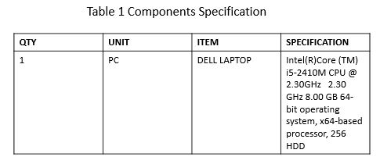 The hardware components the researchers used, together with their specs, are presented in this section. Component dimensions, memory size, and storage are included in the full specs.

**Table 1. Components Specification**

Table 1 shows all the detailed specification consist of components size, operating system, memory capacity and storage.

**Software Requirements**

Software are among the most important interfaces because they describe the differences between the system and other software components (name and version), including the database, operating system, tools, libraries, and integrated commercial components. The proponents made use of a wide range of tools, including the browser, the Xampp server, the PHP programming language, and Visual Studio Code for their code.

**Software Specifications**

The following table represents the minimum and recommended software specifications. Software interface is one of the most essential interfaces, which explains the differences between the system and other software components (name and version), such as the database, operating system, tools, libraries, and integrated commercial components.

|  |  |  |
| --- | --- | --- |
| **Software** | **Minimum** | **Recommended** |
| Operating System | Windows 7 | Windows 10 |
| Disk Space | 30 GB | 30 GB or 100 GB |
| RAM | 2304 MB | 2-12 GB |
| CPU Cores | 2 | 2 or higher |
| Database | Mysql 8.0 | Mysql 8.0 |
| Visual Studio Code | VS Code version 1.74.2 | VS Code version 1.74.2 |
| Xampp Server | 7.0 | 8.0 or higher |

T**able 2. Software Specifications**

Table 2 shows that the advocates used a variety of platforms, including Java for the language, Visual Studio code for the programs, and a browser to view the results.

**Functional Requirements**

Functional requirements are concerned with the system's process and function. This comprises how the system should function, from its administrator to its end users.

**Non-Functional Requirements**

* To prevent bookings from bots, use encryption.
* Search results should appear in a reasonable amount of time.
* In the event of invalid input, users should be suitably assisted in filling up the essential fields.
* The system should accept payments made using a variety of methods.
* Accessible, effective, and simple to use
* Record all actions, documentation, and responses.

**Operational Requirement.**

When a guest makes a safe online reservation through a hotel's website, the system that handles that reservation takes care of it. After that, the information is sent to a backend platform that hotels can use to manage reservations. It might also include other features, including automated email confirmations of reservations.

**Performance Requirement.**

**•** The duration of time required for the client to load following the completion of the online reservation.

**•** The length of time that the consumer must wait for the reservation to be approved and confirmed.

**Security Requirement.** The researchers initially evaluated the definition of a security necessity before determining whether or not the application is secure. Only individuals with authorization can access the system, including the researchers. For security reasons, the system can only be accessed by the administrator, as some data must remain private.

**Chapter III**

**Design and Development Methodologies**

The creation of the Huanying Hotel Online Reservation System will be covered in this chapter. This chapter explains the methods and processes used to gather and analyze the study's data. It includes more than just methods, which are organized sequences of actions, skills, design outputs, and procedures divided into sub-phases that support system developers in managing, controlling, and assessing research as well as choosing the right techniques for each stage of a project.

**Development Method**

The research methodology utilized in this study is the "Interview" approach, which tries to get data from the client by having them respond to questions with pre-made replies before choosing the best one. The researchers utilize this strategy because it makes it simple to aggregate and quantify data. A qualitative research approach based on observations from actual modeling projects and interviews is suggested to achieve the research goals. Additionally, we used a descriptive method that is similar to a validated questionnaire that enables users to learn more about the functionality of the created system.

Figure 9 shows how the technique produces continuous release cycles with tiny, incremental modifications from one release to the next. Each iteration ends with a test of the final result. The Agile technique helps teams involve business stakeholders and get input throughout the project. It also helps teams discover and address minor project issues before they become more significant problems. Agile's phases include gathering requirements, analyzing, designing, coding, testing, and maintenance.

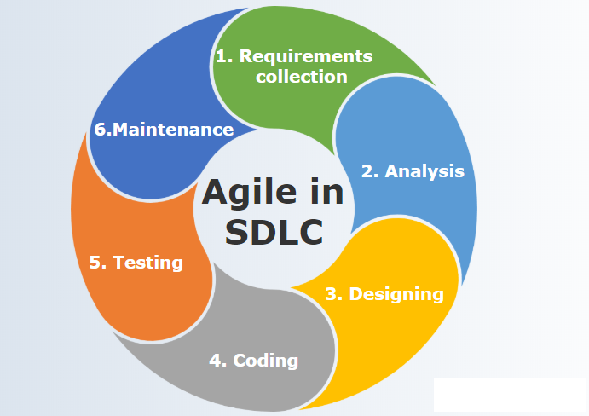

**Figure 9. SLDC Agile Model**

1. **Requirement Collection**

In this stage, research is conducted to obtain data and conduct client interviews to gather information for the Huanying Hotel Online Reservation System project.

1. **Analysis**

The researchers examined a system that had already been created. The researchers had to determine what was wrong with the existing system during the analysis phase. The issues raised will be looked at in order to offer a broad advice on how to make these improvements or upgrade the system.

1. **Design**

The researchers started building the system around the user's needs during this stage. After the specifications for the system were established, a rapid or preliminary design was built.

1. **Coding**

The researchers began developing with PHP software during this stage and constructing a system that enables the user to feel or see how the system works.

1. **Testing**

In order to determine whether the system was operating properly at this stage, the researchers conducted a number of tests. To ensure that the user's needs are met and any defects are fixed, the researchers gave all responders a demonstration of how it operates. The researchers utilized acceptability testing, unit testing, and negative testing.

1. **Maintenance**

At this time, the system had been put into use, and the client had evaluated it. So that the researchers could address any problems as quickly as possible, the client also looked to see if there were any. To make sure the system operates properly, the researchers protected it day by day

**System Design**

**Database Design**

One of the critical stages in the study's development was the system design. This stage displayed the characteristics of the system's entities. The attributes of existing entities are made available to the user in this way. It gives a description of the study's data.

|  |  |  |  |  |
| --- | --- | --- | --- | --- |
| FIELD NAME | DATA TYPE | SIZE | DEFAULT | DESCRIPTION |
| room_id | Int | 11 | NOT NULL | Room ID |
| room_name | Varchar | 100 | NOT NULL | Room Name |
| room_category | Varchar | 100 | NOT NULL | Room Category |
| max_person | Int | 11 | NOT NULL | Maximum Person |

**TABLE 3. FIELD FOR ROOMS**

Table 3 contains the fields for rooms. It contains the room_id, room_name, room_category, and max_person, room_id is the primary key of this table.

|  |  |  |  |  |
| --- | --- | --- | --- | --- |
| FIELD NAME | DATA TYPE | SIZE | DEFAULT | DESCRIPTION |
| category_id | Int | 11 | NOT NULL | Category ID |
| category_name | Varchar | 50 | NOT NULL | Category Name |
| availability | Int | 11 | NOT NULL | Availability |
| description | Text |  | NOT NULL | Room Description |
| image | Text |  | NOT NULL | Room Image |
| price | Double |  | NOT NULL | Room Price |
| max_persons | Int | 11 | NOT NULL | Maximum Persons |
| size | Int | 11 | NOT NULL | Bed Size |
| bed | Int | 11 | NOT NULL | Bed Type |
| Status | Varchar | 50 | NOT NULL | Availability of Rooms |

**TABLE 4. FIELD FOR ROOM CATEGORY**

Table 4 contains the fields for room category. It contains the category_id, category_name, availability, description, image, price, max_persons, size, bed, status, category_id is the primary key of this table.

|  |  |  |  |  |
| --- | --- | --- | --- | --- |
| FIELD NAME | DATA TYPE | SIZE | DEFAULT | DESCRIPTION |
| user_id | Int | 11 | NOT NULL | User ID |
| username | Varchar | 100 | NOT NULL | Login User Name |
| password | Varchar | 200 | NOT NULL | Login Password |
| role | Varchar | 50 | NOT NULL | User Role |
| token | Varchar | 25 | NOT Null | Security Token |
| status | Varchar | 50 | NOT NULL | Verified or not |

**TABLE 5. FIELD FOR USER**

Table 5 contains the fields for user. It contains the user_id, username, password, role, token, status, user_id is the primary key of this table.

|  |  |  |  |  |
| --- | --- | --- | --- | --- |
| FIELD NAME | DATA TYPE | SIZE | DEFAULT | DESCRIPTION |
| Customer_id | Int | 11 | NOT NULL | Customer ID |
| firstname | Varchar | 50 | NOT NULL | Customer First Name |
| lastName | Varchar | 50 | NOT NULL | Customer Last Name |
| middlename | Varchar | 50 | NOT NULL | Customer Middle Name |
| address | Varchar | 200 | NOT NULL | Customer Address |
| gender | Varchar | 50 | NOT NULL | Customer Gender |
| birthday | Date |  | NOT NULL | Customer Birthday |

**TABLE 6. FIELD FOR CUSTOMER**

Table 6 contains the fields for customer. It contains the customer_id, firstname, lastname,middlename,address,gender, and birthday. customer_id is the primary key of this table.

|  |  |  |  |  |
| --- | --- | --- | --- | --- |
| FIELD NAME | DATA TYPE | SIZE | DEFAULT | DESCRIPTION |
| Staff_id | Int | 11 | NOT NULL | Staff ID |
| Staff_name | Varchar | 50 | NOT NULL | Staff Name |
| Age | Varchar | 50 | NOT NULL | Staff Age |
| Gender | Varchar | 50 | NOT NULL | Staff Gender |
| Position | Text |  | NOT NULL | Staff Position in the management |

**TABLE 7. FIELD FOR STAFF**

Table 7 contains the fields for staff. It contains the staff_id, staff_name, age, gender, position. staff_id is the primary key of this table.

**Architectural Diagram/ Block Diagram**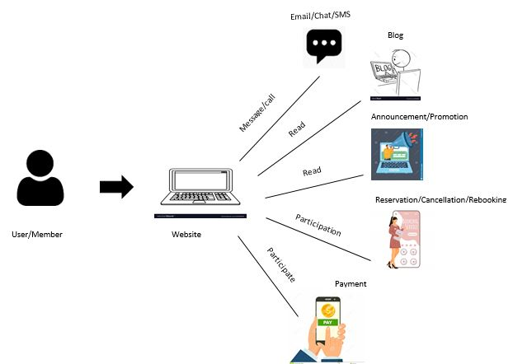

**Figure 3. System Architecture of Huanying Hotel Official Website**

Figure 3 shows the system architecture of the APTM Official Website. The user should register and pay membership fee in order to access all the features and functions of the APTM Official Website

**Data Flow Diagram (DFD)**

The researchers examined the manual process flow of the existing system and created a data flow diagram to compare and decide on a system improvement. The data flow diagrams will make it easier to understand how data flows within an application and between various system operations.

**DFD Level 0**

The diagram 0 is presented below showing the overall process or context of how the system works.

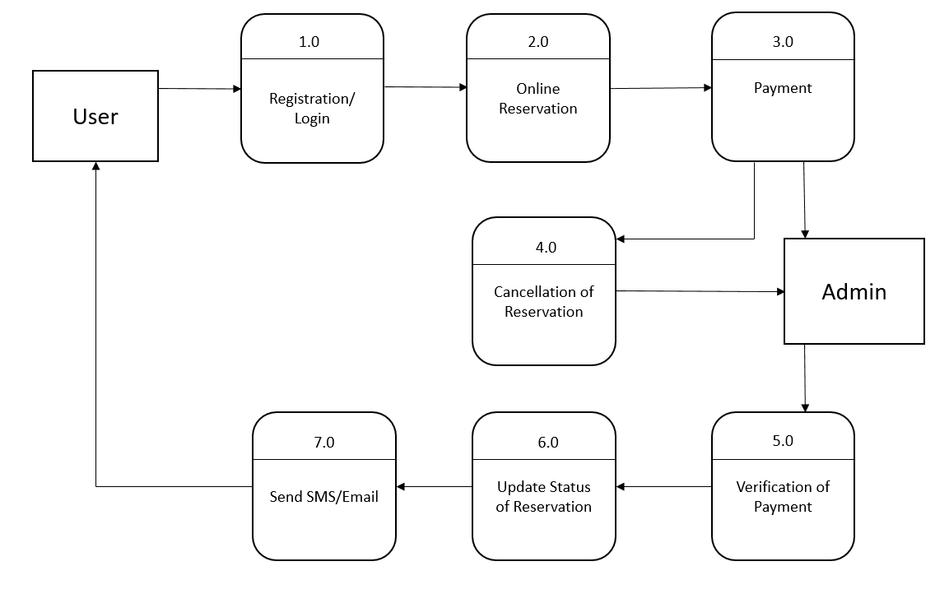

# Figure 4. Data Flow Diagram of the Proposed System

Figure 4 displays the advanced level of the Huanying Hotel Online Reservation System. With regard to online reservations, it shows a general overview of the entire system.

**UML Use-case Diagram**

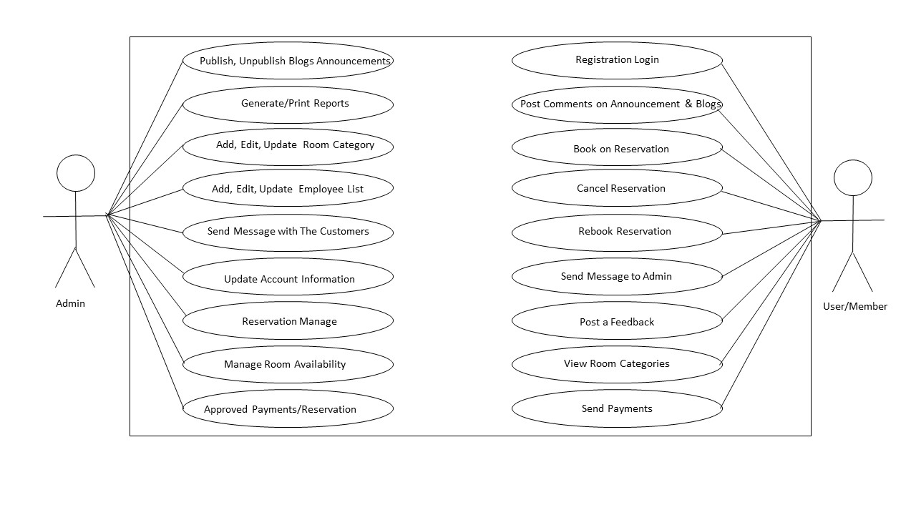

**Figure 5. Use Case for the Developed Website**

Figure 5 shows the process to be done by the users in the developed website. This view presents the users perception of the functionality provided by the proponents of the project.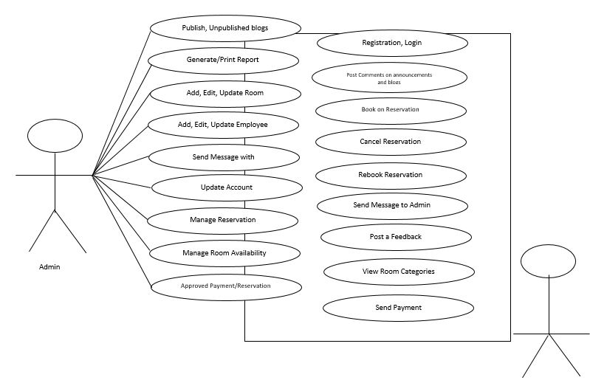

**Diagram of a data flow (DFD)**

The researchers examined the manual process flow of the existing system and created a data flow diagram to compare and decide on a system improvement. The data flow diagrams will make it easier to understand how data flows within an application and between various system operations.

**Context Diagram**

The relationship between the project, actors, and outside forces is depicted in this section. In terms of identifying the system's primary procedure, the owner of the Huanying Hotel will profit from the system's implementation. This depicts the project and outside parties from a broad perspective.

**Figure 7. Context Diagram**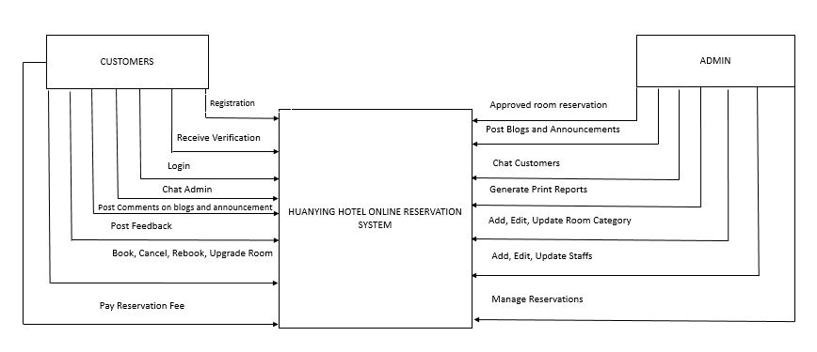

Figure 7 demonstrates the project Huanying Hotel Online Reservation System context diagram. The procedure of the system by which the suggested system will largely function is explained in the diagram that was previously displayed.

**Sample Mock-up**

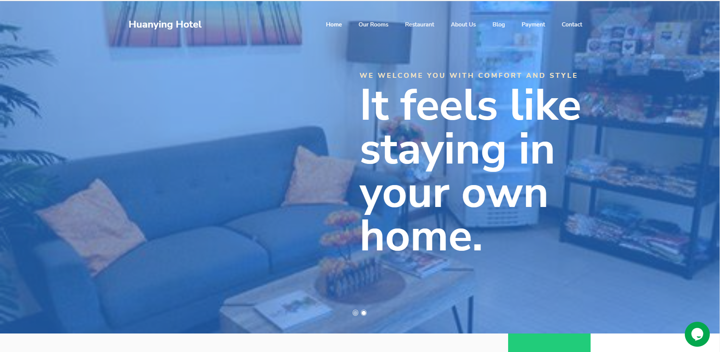

**Figure 8. Mock-up design of the system**

Figure 8shows a picture of each room, information on the various food items offered by the restaurant, our blog, payment options, contact information, and the ability to select certain rooms are all visible in this system. A check-in date, check-out date, chosen room, and guests are also included.

**Gantt Chart**

The four-month planning and system development process used by the researchers is shown in this table. It lists all the tasks that have due dates and are required to be finished. Depending on how long it takes for each phase to be finished and how long it takes the researchers to move on to the next stage, each component of the agile model is distinguished. One of the criteria is to gather information, such as papers, articles, or data.

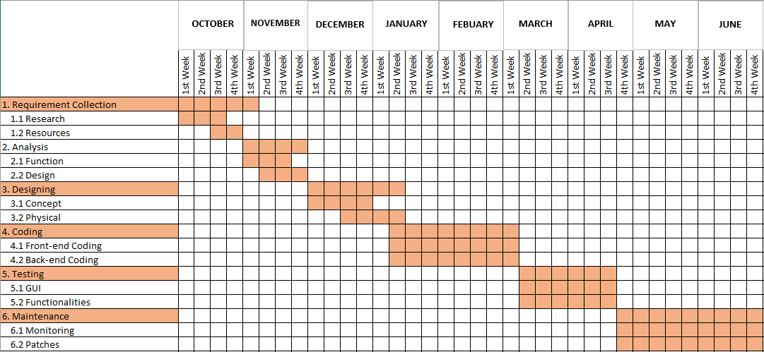

**Figure 3. Gantt Chart**

LEGEND:

This table depicts how the researchers planned and built the system utilizing the agile model over four months. It displayed the various tasks that were completed on a certain date. Each component of the agile model is differentiated base on the amount of time it takes to complete each step and the amount of time it took for the researchers to move on to the next stage. Gathering information, such as articles, data, or papers, is one of the requirements.

**Testing**

The system has been put through several tests by the researchers, who have assessed these important results. The researchers have evaluated what needs to be changed or improved based on the findings. The effectiveness of the system can be evaluated and analyzed with the use of testing.